**Problem 2: A mixture problem**

Part A

i)

Each ingredient of the 8 ingredients in the salad will be assigned as if it is an array. The optimal solution will be a combination of the ingredients. Variables are:

* T = Tomato
* L = Lettuce
* S = Spinach
* C = Carrot
* SS = Sunflower Seeds
* ST = Smoked Tofu
* CP = Chickpeas
* O = Oil

Additionally, each ingredient will have an assigned variable for nutritional value as follows:

* P = Protein
* F = Fat
* C = Carbohydrates
* S = Sodium
* LG = Leafy Greens

Given nutritional content of the ingredients:

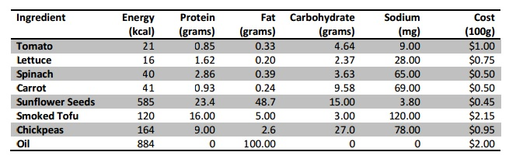

Our goal is to minimize the amount of calories but still meet a specific nutritional requirement. Each salad must contain:

* At least 2 but no more than 8 ingredients.
* At least 15 grams of protein
* At least 2 and at most 8 grams of fat
* At least 4 grams of carbohydrates
* At most 200mg of sodium
* At least 40% leafy greens by mass

Given the provided requirements for a salad we can derive some constraints for our linear program:

* P >= 15
* 2 <= F <=8
* C >= 4
* S <= .2
* LG >= .4(mass)

ii)

Using LINDO, we can determine the optimal solution for this program with the following code:

MIN 21T + 16L + 40S + 41C + 585SS + 120ST + 164CP + 884O

ST

0.85T + 1.62L + 2.86S + 0.93C + 23.4SS + 16ST + 9CP >= 15

0.33T + 0.20L + 0.39S + 0.24C + 48.7SS + 5ST + 2.6CP + 100O >= 2

0.33T + 0.20L + 0.39S + 0.24C + 48.7SS + 5ST + 2.6CP + 100O <= 8

4.64T + 2.37L + 3.63S + 9.58C + 15SS + 3ST + 27CP >= 4

9T + 28L + 65S + 69C + 3.8SS + 120ST + 78CP <= 200

0.4L + 0.4S 0.6T

0.6C

0.6SS

0.6ST

0.6CP

0.6O

>= 0

T >= 0

L >= 0

S >= 0

C >= 0

SS >= 0

ST >= 0

CP >= 0

O >= 0

END

Results of the code will be attached to this report titled Problem 2-A Lindo Results.txt.

iii)

The lowest calorie salad solution:

|  |  |  |  |
| --- | --- | --- | --- |
| Ingredient | Calories | Cost ($) | Nutrition |
| Lettuce (1.220836 units) | 20 | $0.92 | 1.98g Protein  .24g Fat  2.89g Carbohydrates  34mg Sodium |
| Smoked Tofu (.813890 units) | 98 | $1.75 | 13.02g Protein  4.07g Fat  2.44g Carbohydrates  98mg Sodium |
| Totals: |  |  |  |
| Lettuce and Smoked Tofu | 118 | $2.67 | 15g Protein  4.31g Fat  5.33g Carbohydates  132mg Sodum |

As you can see, this combination meets all of our requirements outlined above.